Final Project Report

Introduction:

* The purpose of this plan is to build a website for rare/collectible book sellers and buyers. This is a fictional store located in Winnipeg MB called RARE BOOKS INC. with a significant library of collectible books. The owner buys and sells rare books from/to collectors locally and globally.
* The owner wanted to create a web presence to offer services online. These services include:
  + Advertise his services online
  + List books for sale
  + Allow users to submit information regarding books for sale
  + Allow users to book appointments for appraisals and sales of large collections

Design:

* Target Audience:

|  |  |  |  |  |
| --- | --- | --- | --- | --- |
| **User Group** | **Functions Performed** | **Age** | **Gender** | **Web Experience** |
| Book Buyers | View Catalogue of Books  Search Catalogue of Books  Place Orders  Make Payments  Arrange Shipping  Request More information / Contact  Find Store Contact Information  Store Hours  Place requests to locate and procure books not in stock | 18+ | M/F | Varies |
| Book Sellers | Create listings to review offerings  Request More information | 18+ | M/F | Varies |
| Customers requiring appraisals | View appointment schedule  Arrange appointments for estate appraisals | 18+ | M/F | Varies |
| External dealer consultations | Request Information / Contact | 18+ | M/F | Varies |

1. Goals

* Expand sales by expanding into the internet/global market
* Expand appraisal services beyond brick and mortar offerings
* Recruit Employees as business grows
* Facilitate customers searching books available for sale
* Provide more information on rare books

1. Main Topic Area

* Who we are
* Shop for books
* List estates/collections for review
* Request Appraisals
* Contact Us
* Careers

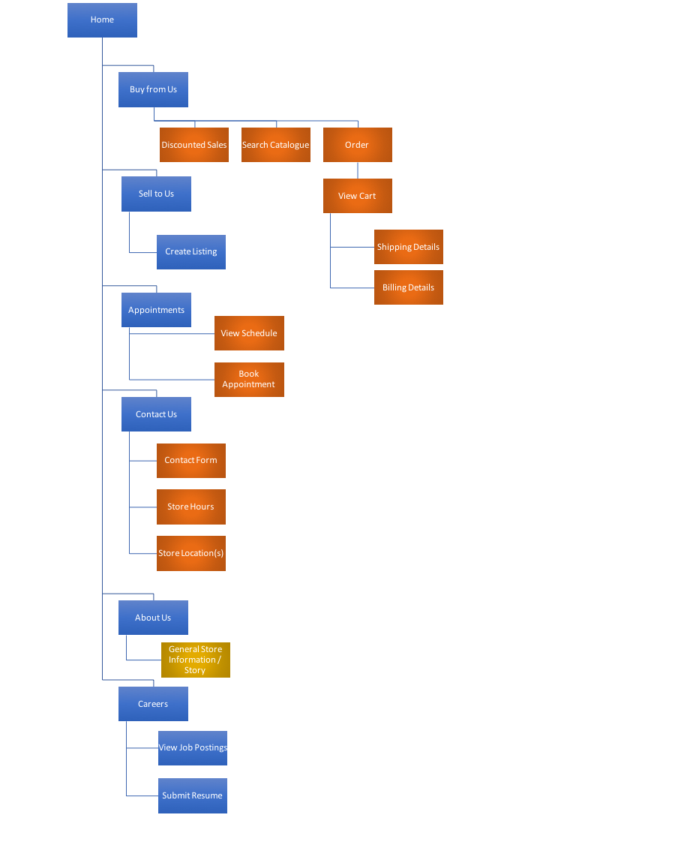Original Planned Structure:

Buy From Us:

It was determined that creating a cart and full online order system was beyond the scope of this project as we have no back-end developer available. Instead, a selection of books is available to browse.

Appointments:

It turned out there was no need to have multiple sections under the Appointments section. Both operations (View Schedule and Book Appointment) are currently available for users. There is no contact form because users have the ability to send emails through the menu and additional links found on the website

Contact Us:

The Contact Us page was eliminated from the final website and was replaced with an ‘E-Mail Us’ link available on every page in the menu. The store hours and location were moved to the main Home page since they are key points of interest and should be more prominent/available.

|  |  |  |
| --- | --- | --- |
| Category Name | Folder Name | Final Structure |
| Buy From Us | BuyFromUs | Browse.html |
| Discounts | BuyFromUs/Discounts | Not Used – out of scope |
| Search Catalogue | BuyFromUs/Search | Not Used – out of scope |
| Order | BuyFromUs/Order | Not Used – See browse.html |
| View Cart | BuyFromUs/Order/Cart | Not Used – out of scope |
| Shipping Details | BuyFromUs/Order/Cart/Shipping | Not Used – out of scope |
| Billing Details | BuyFromUs/Order/Cart/Billing | Not Used – out of scope |
| Sell To us | SellToUs | Sell.html |
| Create Listing | SellToUs/CreateListing | Sell.html |
| Appointments | Appointments | Appointments.html |
| View Schedule | Appointments/ViewSchedule | Appointments.html |
| Book An Appointment | Appointments/Bookings | Appointments.html |
| Contact Us | ContactUs | See Email-Us link on main menu |
| Contact Form | ContactUs/ContactForm | No contact form required – see E-Mail link in menu |
| Store Hours | ContactUs/Hours | Moved to index.html |
| Store Location | ContactUs/Location | Moved to index.html |
| AboutUs | AboutUs | About-us.html |
| Our Story | AboutUs/OurStory | About-us.html – no additional section necessary |
| Careers | Careers | Careers.html |
| View Postings | Careers/Postings | Careers.html – no additional section necessary |
| Submit Resume | Careers/Apply | Careers.html – no form required as all postings have links to email resume. No additional section necessary |

The diagram above shows six main areas of the website. The section under About Us contains broad information regarding the business’s offerings as well as a story of the company’s history and family-run operation. It is a heartwarming story of a father who built his business over 40 years and inspired his son to take it over and shares in his love of rare books.

**The original Buy From Us section was planned as follows:**

Under Buy From Us a customer selects inventory from the listings in this section, adding items to their cart. When ready to place the order they view their cart, make any final edits, review prices and taxes. Next they provide shipping details and select from shipping options. Finally they provide payment information and upon approved processing the order is created and confirmed with the user.

**Buy From Us was modified to single section called Browse:**

There was insufficient budget to enlist the skills of a back-end developer so building out an order system was determined to be out of scope for this project. Instead, after consulting with the owners, it was decided that we could list a selection of the store’s catalogue on this page to give users an idea of the store’s offerings. There is great potential to build out an order system down the road if the owner’s deem it worthwhile.

Under Sell To Us, sellers can create listings, upload images of their collection and fill in details about the books they would like to sell: Author, publication date, publisher, condition. This information is only reviewable by company staff.

Appointments allows users to view the appointment schedule and book appointments for in-person appraisals. The appointment table is clickable although it doesn’t reset as we had limited time to develop any javascripts required to truly make this an interactive experience.

The Contact Us section was eliminated from this website as all information that was originally destined here was deemed too important to place anywhere other than the landing page. To contact the store, an Email-Us link was placed in the menu. Store hours and location are now in index.html (the landing page).

The Careers section allows potential employees to review job listings and available positions as well as apply directly to those positions using a simple submission form that includes some personal details as well as uploading resumes in PDF or word format. The submission is a simple email with the email-to field filled out with: [careers@rarebooks.com](mailto:careers@rarebooks.com).

1. Navigation

The Tree Diagram above does not tie directly to the website’s navigation menu system. It was originally planned to have a horizontal menu bar at the top of every page but was later determined that using a side-panel was preferable however this may have been a poor decision as a horizontal menu would have been easier to implement. Balancing the padding and margin to keep things aligned across the page was challenging

The primary navigation method used is a static menu bar on every page of the site to allow easy and fast navigation to/from every section of the page. The **original** design of the menu bar uses a high contrast color scheme of dark blue background with white text as shown here:

Background-color: #5E81BF;

A

Color: white;

The final menu items were styled slightly differently to better match the colors found in the supplied the images using the following colors:

A

Background-color: #2D6886;

Color: #FFF;

The **original** Current Section was to show up with the following style:

A

Background-color: #68E1FB;

Color: black;

After reviewing the images and the overall style of the website it was determined that the styling of the current section should be as follows to better keep the overall look of the website consistent (this color scheme matches the title header at the top of each page:

Background-color: #212529;

A

Color: white;

Originally we were going to use a company logo in the top left of each page however the vendor is still working with his graphic designer and they have not finalized the logo for the company as of yet. The owner was fine continuing without this element.

**Original plan for page titles:**

Page titles show the current section user’s are browsing just under the menu bar using the heading 5 tag

**Final Result:**

The decision was made to change each page’s title (shown by the browser on each tab) as well has having a static title bar at the top of each page. Because of the required positioning of this title bar a custom styled div was used instead of a heading 5 tag.

**Original Plan for the home page:**

The home page contains a large image slider that shows the exterior and interior photos of the brick and mortar store.

**Final Result:**

Instead of having an image slider, large format images are visible on each page, each image is different but in a common theme of old and rare books. This helps keep consistency across the website as well as give users a visual indicator as to where they are within the website. An image slider would also increase load-times and may further deter users from using the site if there was a wait time for loading.

**Project Log:**

1. May 11 contacted by store owner of Rare Books Inc to design website for their business
2. May 13 began planning website, selecting preliminary colors and layout options, target users identifying required features and major goals of the website
3. May 15 continued fleshing out styles and options
4. May 16 Determined required sections for content
5. May 18 Started looking at menu options for navigating the website
6. May 19 horizontal menu determined to be best option
7. May 21 Determined file structure of website
8. May 22 wrote up project plan
9. May 23 began development of website including skeleton file structure
10. May 25 Began layout of index.html using lorem ipsum placeholder text
11. May 26 Started appointment section and identified there was no need to have sub-sections within this page.
12. May 30 Started working on browse section and began to realize that a full-blown order workflow was potentially beyond the scope of this project.
13. June 1 Started looking at other options for the browse section of the website, perhaps just a listing of books. Put placeholder listings in this section
14. June 3 Laid out Sell.html. At this point it was clear that some styles had to be refactored as the number of similar styles across the current pages was becoming difficult to maintain. Moved styles out from in-line and internal to an external stylesheet.
15. June 4 With the styles moved to an external stylesheet I was able to produce the rest of the pages much faster simply applying styling classes to the html elements. Since the layout of most of the pages is very similar it was easy to complete laying out these pages
16. June 6 Refactored the menu system to be a vertical static panel but styling it with hover and current was still outstanding
17. June 7 Created favicon.ico and downloaded images for page content – ALL Public Domain as indicated in the comments in index.html
18. June 8 Added appointment schedule table to appointments page
19. June 9 Added job posting sections to careers.html
20. June 10 Added styles to appointment schedule table
21. June 11 Added footer sections on all pages indicating copyright
22. June 12 Determined Contact Us was not needed as Email link could be placed in menu
23. June 13 Replaced Lorem Ipsum content with store hours and location as well as general information on index.html
24. June 14 Came up with book listings for browse.html
25. June 15 Reworked the styles the book listings for browse.html
26. June 16 created right side panel for index.html, struggled with the styling, height and width of this vertical panel to keep all page elements aligned.
27. June 17 Used right panel on index.html to show ‘like us’ links for facebook, Instagram and twitter.
28. June 18 Added custom form on the sell.html – no styling just determined the basic form elements to use
29. June 19 Styled sell.html form to ensure a better user experience
30. June 20 Updated appointments.html with simple javascript to allow users to click table cells changing the background color to red for available slots. Also updated the content on the page with instructions on how to book an appointment
31. June 21 Received copy for About Us page and filled that in and styled it according to the rest of the site
32. June 22 Determined that individual icons for each listing on browse.html was not feasible given the number of listings and decided to use one icon/image for each listing to help differentiate between each individual lising (rather than a simple table)
33. June 23 Added static title bar to each page to help indicate where users were within the website
34. June 24 Updated menu styles to better indicate to users this was a menu. Only accomplished the highlighting on hover
35. June 25 Continued to update menu to better show where users were with the site by creating a custom css class and applying it to each page’s main menu item.

**Problems & Solutions:**

Contact Us was determined as unnecessary. There is a link in the main menu on every page and the content originally destined here (store location & hours) better fit on the main page of the website due to its importance.

The order system was scrapped early on but not entirely abandoned. As a book merchant, it was determined that listings were important however a full-blown order system is beyond the scope of this project.

The appointment booking feature would be better if people could click a slot and fill out a form however, with no back-end infrastructure, a simple email will have to suffice.

The sell to us page has a form however it doesn’t go anywhere. This is going to have to be circled back on when we get a back-end developer and can submit this information to a database for the store owners to use more effectively.

The menu highlighting was somewhat challenging to accomplish without the use of external libraries however a little google-fu (searching) and the problem was overcome with ease.

Laying the side panels was difficult. Each additional element on the page needs to be considered/modified to keep all elements in line. This additional overhead sure gives me appreciation for javascript/css libraries that make grid layouts standard and easy to build.

**Website Highlights:**

I think the overall style of the website is something worth noting. Although using an external stylesheet makes it much easier to maintain consistency across html pages, it still great to see a website that has a nice warm feel and reminds users of a physical book. The images selected and colors chosen for text and background colors tie well.

The appointment schedule with the simple javascript to provide a little interactivity is something I think deserves some highlighting.

Using scrollable divs to allow for the layout I chose is also a nice feature and more difficult than a stack of vertical elements scrolling down a page. This also allows more content to be placed on a single screen and I think balance was achieved in terms of keeping the content separate and uncluttered.

**Conclusions and Comments:**

I learned a lot from building this site in terms of organization and compromising my original plans. I had to think about some problems many times in different ways and generally was able to come up with some kind of solution. These challenges often lied with the fact that there is no back-end so the features people would expect on a typical website had to be modified to be usable as-is.

I found myself doing the bulk of my research online as there is an abundance of information on html, css and all other web design and development topics. It was a pure pleasure to learn more on this topic. I plan on continuing down the path of a web developer.

**References:**

* + - Stackoverflow.com (several articles)
    - W3schools.com (several articles)
    - Sitepoint.com (several articles)
    - W3c.org (several articles)